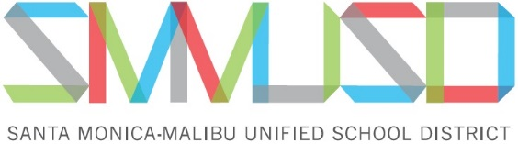

***BOARD NOTES***

**Board of Education Regular Meeting – Thurs., June 1, 2023**

*Board Notes is provided as a public information service from the Office of the Superintendent and is intended to provide an immediate summary of the Board of Education’s action and discussion on significant projects and services from the most recent board meeting. Not all items that were listed on the board agenda are included in this report. Please contact the Superintendent’s Office (310.450.8338 x70229) with questions about this summary.*

**Upcoming board meetings in June 2023:**

* Thurs., June 22, 2023, 5:30 p.m. *(special meeting at the DO and via Zoom)*
* Thurs., June 29, 2023, 5:30 p.m. *(regular meeting at the DO and via Zoom)*

**The board took action on the following:**

* The board adopted its annual resolution honoring Juneteenth, which recognizes June 19, 1865, as a day that symbolizes freedom, celebrates the abolishment of slavery, and reminds all Americans of the significant contributions of African Americans to our society.
* The board adopted a resolution honoring Jewish American History Month, which is in May (this resolution will be adopted each May in future years). The resolution pays tribute to the generations of Jewish Americans who helped form the fabric of American history, culture, and society.

**The board discussed the following:**

* Ed Services presented the preliminary Local Control Accountability Plan (LCAP) for 2023-24. A public hearing on the LCAP will be held during the June 22 special board meeting, with approval slated for the June 29 regular board meeting.
* Fiscal staff presented the preliminary General Fund Budget for 2023-24. A public hearing on the budget will be held during the June 22 special board meeting, with approval slated for the June 29 regular board meeting.
* The Health & Safety DAC presented its end-of-year reports to the board. The remaining DAC reports will be presented on either June 22 or June 29.

**Special Note:**

* The board honored the 2022-23 SMMUSD retirees.
* The board thanked outgoing Student Board Members Mira Wagabaza and Irina Columbeanu for their service to the board this year.
* The board approved the appointment of Dr. Antonio Shelton as our new Superintendent, effective July 1. Dr. Shelton had been serving as our Executive Director of Secondary Schools in Santa Monica.
* The board approved the appointment of Mr. Jose Cuevas as the new Principal of Lincoln Middle School (had been serving as a House Principal at Samohi) and Mr. Greg Pitts as a new House Principal at Samohi (had been serving as an Interim House Principal).

**Upcoming board items (schedule subject to change):**

* Public Hearing: 2022-23 LCAP – *action on 6/22/23*
* Public Hearing: 2022-23 Budget – *action on 6/22/23*
* Adopt 2022-23 LCAP – *action on 6/29/23*
* Adopt 2022-23 Budget – *action on 6/29/23*
* DAC End-of-year Reports *– discussion on 6/22/23 or 6/29/23*